EXPERIMENT NO. 2: ONLINE HOTEL ROOM BOOKING WEBSITE
AIM:
To develop a responsive online hotel room booking web application supporting room search by destination/dates, dynamic pricing calculation, booking history tracking, strict 3-day cancellation/modification enforcement, and admin inventory controls.
PSEUDOCODE (IN 6 SIMPLE POINTS):
Step 1: Initialize room inventory with four primary categories: Standard, Deluxe, Suite, and Executive with fixed tariff rates.
Step 2: Capture user search inputs for destination city, check-in date, check-out date, and total guest count.
Step 3: Filter and display available rooms with pricing breakdown, amenities, and real-time room availability status.
Step 4: Process user room booking, compute overall tariff based on stay duration, and store reservation details in the booking log.
Step 5: Implement cancellation/modification validation logic to ensure requests are submitted at least 3 days before the scheduled arrival date.
Step 6: Provide administrator credentials to update room inventory count, modify tariffs, and oversee customer reservations.
SOURCE CODE:
<!DOCTYPE html>
<html lang="en">
<head>
<meta charset="UTF-8">
<title>Grand Stay Hotel Booking</title>
<style>
body { font-family: 'Segoe UI', Tahoma, sans-serif; margin: 0; background: #f8fafc; color: #1e293b; }
.hero { background: linear-gradient(rgba(15,23,42,0.8), rgba(15,23,42,0.8)), #0284c7; color: white; padding: 40px 20px; text-align: center; }
.container { max-width: 950px; margin: -30px auto 30px; background: white; padding: 25px; border-radius: 12px; box-shadow: 0 4px 15px rgba(0,0,0,0.1); }
.search-grid { display: grid; grid-template-columns: repeat(auto-fit, minmax(180px, 1fr)); gap: 15px; margin-bottom: 20px; }
label { font-weight: 600; font-size: 13px; color: #64748b; }
input, select, button { width: 100%; padding: 10px; border: 1px solid #cbd5e1; border-radius: 6px; box-sizing: border-box; }
button { background: #0284c7; color: white; border: none; font-weight: bold; cursor: pointer; }
button:hover { background: #0369a1; }
.room-card { display: flex; justify-content: space-between; align-items: center; border: 1px solid #e2e8f0; padding: 16px; border-radius: 8px; margin-top: 15px; }
.price { font-size: 20px; font-weight: bold; color: #0f172a; }
.badge { background: #e0f2fe; color: #0369a1; padding: 4px 10px; border-radius: 20px; font-size: 12px; }
.notice { padding: 12px; border-radius: 6px; margin-top: 15px; font-size: 14px; }
.success { background: #dcfce7; color: #166534; }
.error { background: #fee2e2; color: #991b1b; }
</style>
</head>
<body>
<div class="hero">
<h1>Grand Stay Resort & Hotels</h1>
<p>Book premium luxury suites and hotel rooms at guaranteed best rates</p>
</div>
<div class="container">
<div class="search-grid">
<div><label>Destination City</label><input type="text" id="dest" value="Kodaikanal"></div>
<div><label>Check-in Date</label><input type="date" id="checkin"></div>
<div><label>Check-out Date</label><input type="date" id="checkout"></div>
<div><label>Guests</label>
<select id="guests"><option>1 Guest</option><option>2 Guests</option><option>4 Guests</option></select>
</div>
</div>
<h3>Available Room Types</h3>
<div class="room-card">
<div>
<h4>Standard Cozy Room <span class="badge">Available: 8</span></h4>
<p>1 Queen Bed, Free Wi-Fi, Garden View</p>
</div>
<div style="text-align: right;">
<div class="price">Rs. 2,500 / night</div>
<button onclick="bookRoom('Standard Cozy Room', 2500)" style="width: auto; padding: 8px 18px; margin-top: 5px;">Book Room</button>
</div>
</div>
<div class="room-card">
<div>
<h4>Deluxe Sea-Facing Suite <span class="badge">Available: 4</span></h4>
<p>1 King Bed, Private Balcony, Complimentary Breakfast</p>
</div>
<div style="text-align: right;">
<div class="price">Rs. 4,800 / night</div>
<button onclick="bookRoom('Deluxe Sea-Facing Suite', 4800)" style="width: auto; padding: 8px 18px; margin-top: 5px;">Book Room</button>
</div>
</div>
<div id="bookingResult"></div>
<hr style="margin: 30px 0;">
<h3>Manage Active Reservation (3-Day Cancellation Policy)</h3>
<p style="font-size: 13px; color: #64748b;">Reservations can only be modified or cancelled at least 3 days prior to the check-in arrival date.</p>
<input type="text" id="cancelId" placeholder="Enter Booking ID (e.g., HTL-501)" style="width: 250px;">
<button onclick="processCancellation()" style="width: auto; background: #e11d48;">Cancel Reservation</button>
<div id="cancelResult"></div>
</div>
<script>
let currentBooking = null;
function bookRoom(type, price) {
let checkin = document.getElementById('checkin').value;
let checkout = document.getElementById('checkout').value;
if(!checkin || !checkout) return alert('Please select Check-in and Check-out dates');
let d1 = new Date(checkin), d2 = new Date(checkout);
let nights = Math.ceil((d2 - d1) / (1000 * 60 * 60 * 24));
if(nights <= 0) return alert('Check-out date must be after Check-in date');
let total = nights * price;
let bId = 'HTL-' + Math.floor(100 + Math.random()*900);
currentBooking = { id: bId, type, checkin, nights, total };
document.getElementById('bookingResult').innerHTML = `
<div class="notice success">
<strong>Reservation Confirmed!</strong> Booking ID: <b>${bId}</b><br>
Room: ${type} | Duration: ${nights} Night(s) | Total Fare: Rs. ${total.toLocaleString()}<br>
Check-in Date: ${checkin}
</div>`;
}
function processCancellation() {
let bId = document.getElementById('cancelId').value.trim();
if(!currentBooking || currentBooking.id !== bId) {
return document.getElementById('cancelResult').innerHTML = `<div class="notice error">No booking found matching ID ${bId}.</div>`;
}
let today = new Date();
let arrival = new Date(currentBooking.checkin);
let daysUntilArrival = Math.ceil((arrival - today) / (1000 * 60 * 60 * 24));
if(daysUntilArrival >= 3) {
document.getElementById('cancelResult').innerHTML = `<div class="notice success">Booking ${bId} successfully cancelled! Full refund of Rs. ${currentBooking.total} processed.</div>`;
currentBooking = null;
} else {
document.getElementById('cancelResult').innerHTML = `<div class="notice error">Cancellation Rejected: Only ${daysUntilArrival} day(s) remain before arrival. Hotel policy strictly requires cancellation at least 3 days prior.</div>`;
}
}
</script>
</body>
</html>
Output:
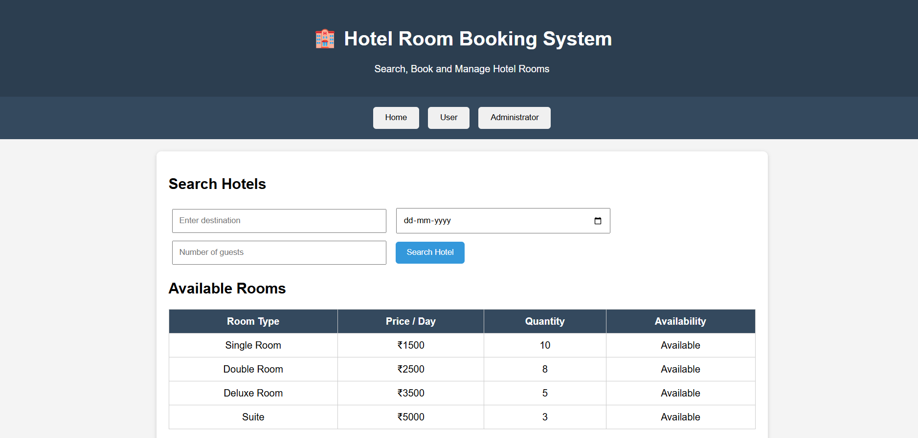
RESULT:
Thus, the online hotel room booking web application was successfully designed and tested, implementing destination search, room booking calculations, booking history, and strict 3-day cancellation policy enforcement.

